Group id : A6

Project Name : Stock Candle

**Assignment 12**

Title: Prepare Sequence Model.

Problem Statement: Identify all major scenarios (sequence flow) for your system.

Draw Sequence Diagram for every scenario by using advanced notations using

UML2.0

Theory :

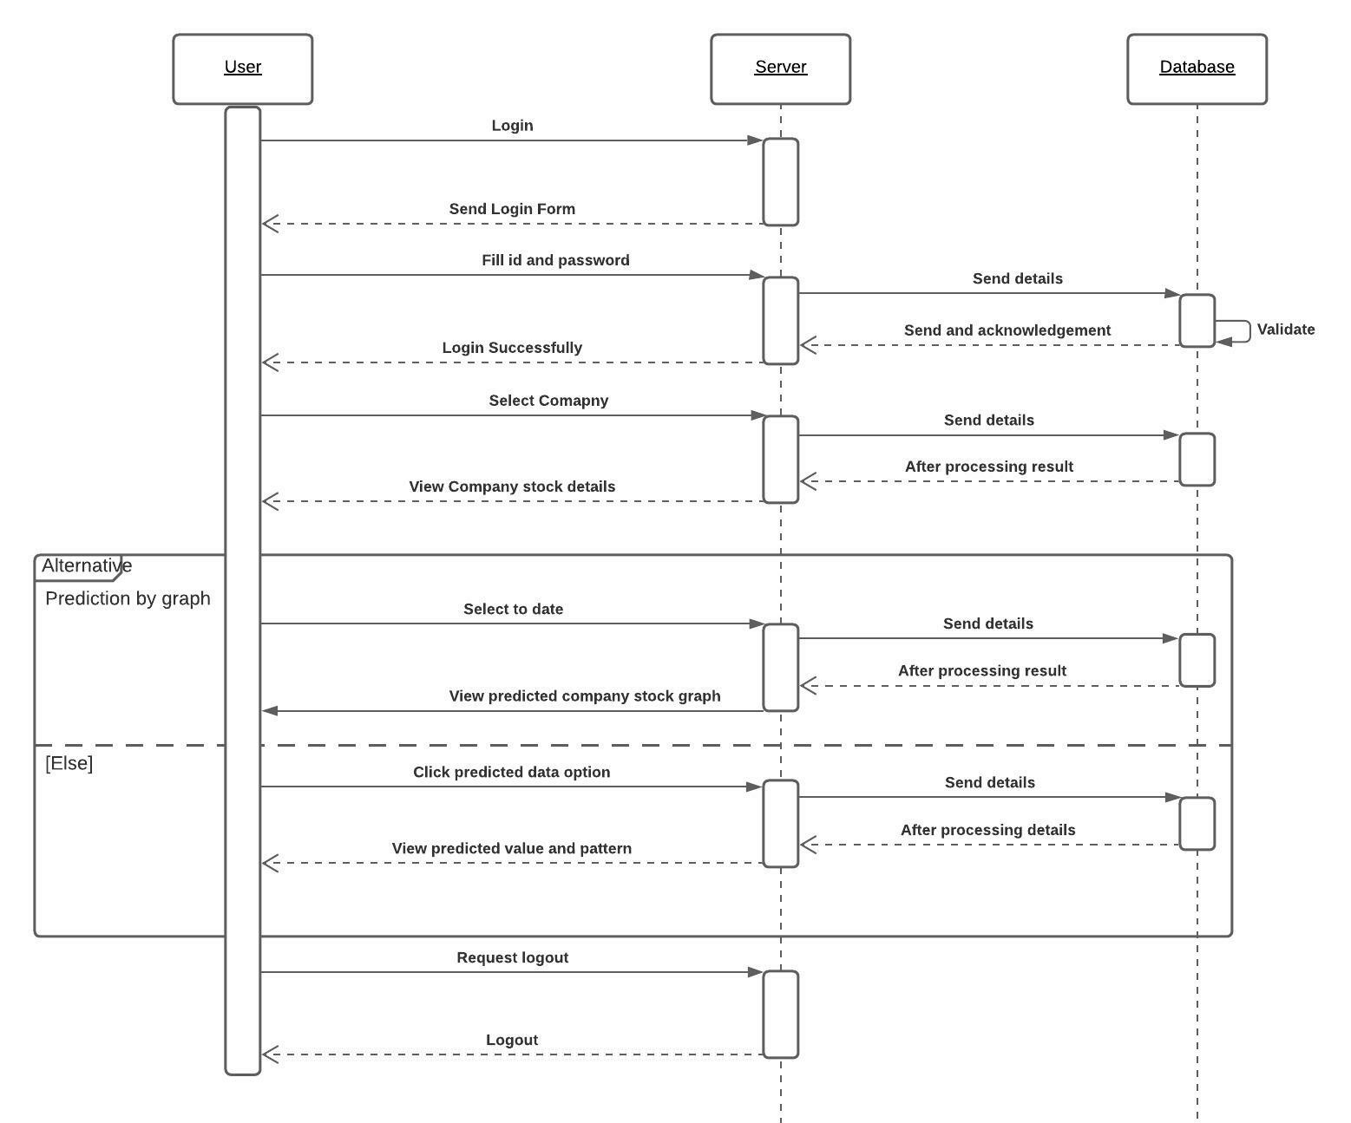

**Conclusion :** Thus, we have prepared uml sequence diagram using advanced uml2 notations and lucid chart.